**BANA 6760 Data Visualization**

**Assignment-10 (EDA Using R)**

**Topic: Tracking Customer Satisfaction**

**and Business Engagement**

**University of Colorado Denver**

**Department of Business Analytics**

**Submitted to**

**Professor: Dr. Ellis**

**Submitted By  
Sai Lokesh Siddanathi**

**Exploratory Data Analysis**

**Objective:**To Analyze the Customer Engagement with the help of EDA to Business and give recommendations

**Dataset:**

This Dataset has 9000+ Records and has 24 variables. It has Customer ID, Personal Details, Response, Education, Vehicles, Employee Status, Gender and so on etc.,

**Goal :** Calculate the Engagement Rate of the customers with the Business.



**1. Analyzing Conversing Rate in Sales Channel – Engaged Vs Not Engaged**

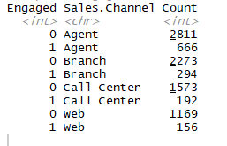

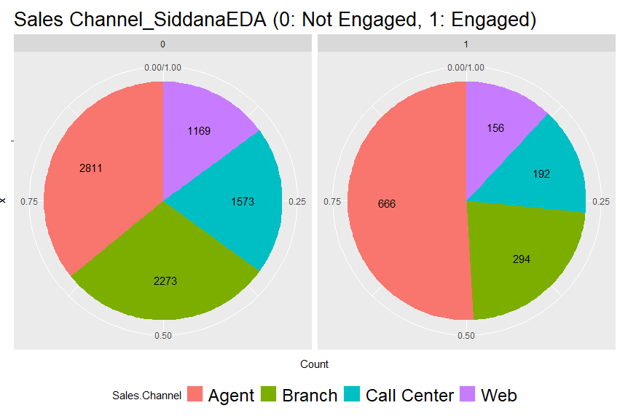

As the pie charts show, more than half of engaged clients came through Agents, whereas non-engaged customers were divided more evenly across all four channels.

2. **Conversion Rate in State:**

Analyzing the conversion rate with respect to state. Listed below is the table which has the Total Count, Number of Conversions and the Conversion Rate.

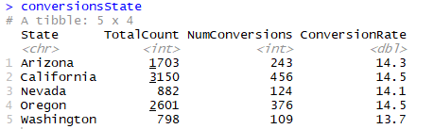

**3. Conversion Rates with respect to Education:**

Conversion Rate with respect to Education is calculated here.

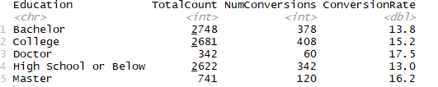

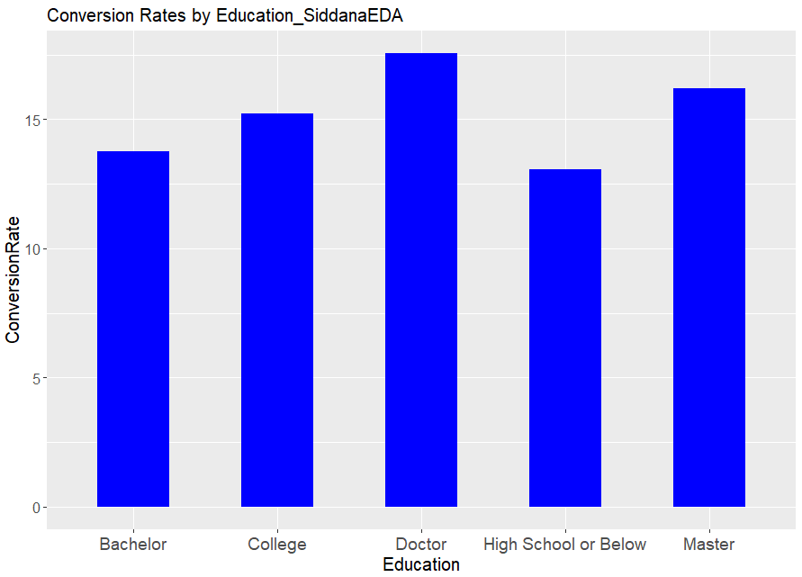

**Observation** : Customers with Doctoral and Master's degrees tend to engage more with the Business.

**4. Conversion Rates by Employment Status**

Conversion Rate is evaluated by the Employment status and below is the graph that explains the categories.

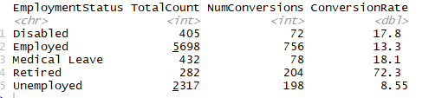

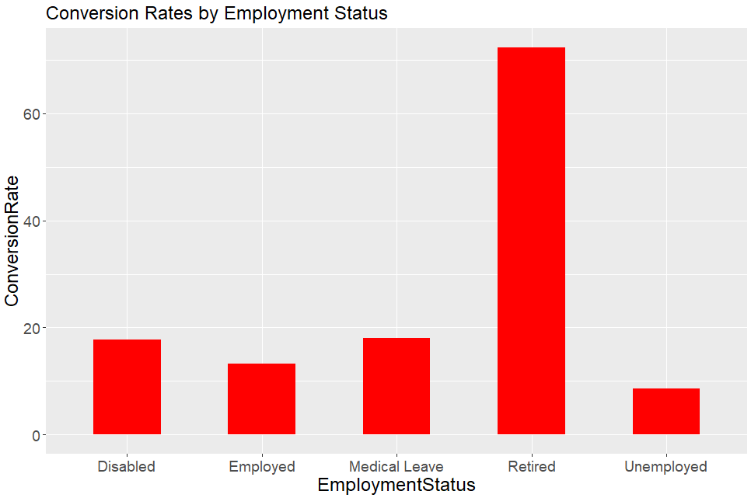

**Observation**: The engagement rate among retired customers is much higher compared to other groups.

**5. Conversion Rate by Gender:**

Conversion Rate by Gender is calculated with respect to Gender and Here there is no significance difference found.

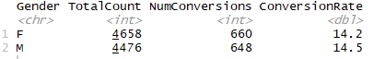

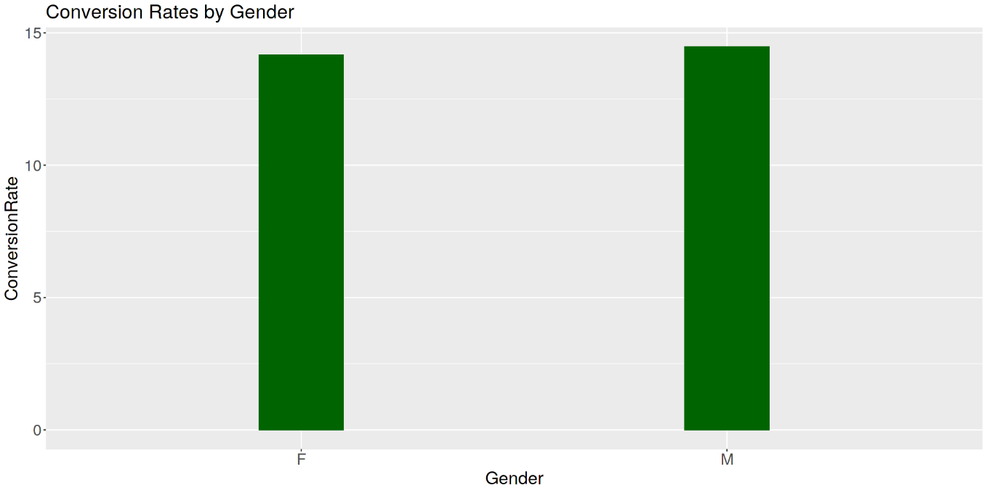

**6. Location Wise Conversion Analysis:**

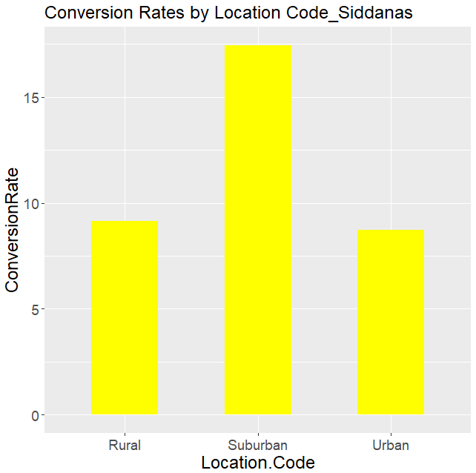

**Observation:** Customers with the location code "suburban" have a 2 times higher engagement rate.

**7. Conversion Rate with Marital Status:**

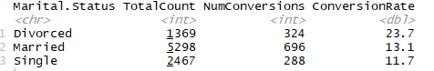

**Observation**: Divorced Customers are more likely to engage

**Result:**

Regression Analysis for finding the significance of Variables and only Income, Number of policies, and Total Claim Amount had significant correlations with the variable Engaged, according to the results of this regression study. Income and Total Claim Amount are positively related to Engaged (coefficients are positive). That means that the higher our clients' income and total claim amount, the more likely they are to interact.